ODBC Drivers, MDAC.

Problems and Solutions

David M Tredgett
Modem Computers Ltd.
Email: dave@modem-computers.co.uk

Copyright. 18th June 2004
ODBC Driver Problems and Solution

Symptom

Error creating database for Pocket Genealogist

20:39:17 Loading Profiles...
20:39:17 Ready
20:41:56 Creating Database 'EppingTredgetts'
20:41:56 Database error: Command='CREATE_DB="C:\Documents and Settings\All Users\Documents\PocketGenealogist\Databases\EppingTredgetts.pdb"'; RC=6, MSG=Component not found in the registry 20:41:56 http://www.pocketgenealogist.com/problems.htm

Confirmation

Check “Data Sources (ODBC)” from “Administrative Tools” in Control Panel. On XP systems. For NT W2K and Win98 this is directly visible in Control Panel.

Try and create a new data source. You should see a full list of drivers

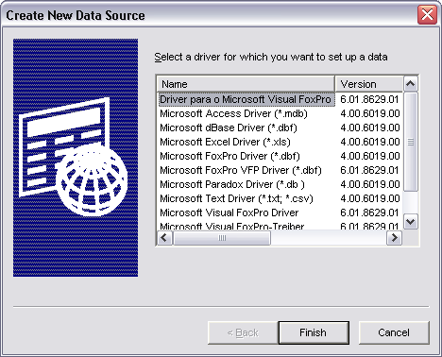

Check the drivers tab, it should look similar to this….

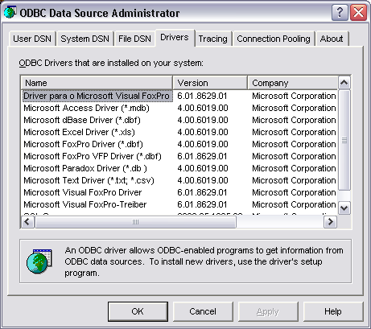

If only one or two items, or possibly none at all, are shown, there is a problem.

Explanation.

ODBC definitions are stored in two locations,

- odbc.ini and odbcinst.ini in C:\WINDOWS and
- System registry.

Contrary to popular belief, the .ini files are created from the registry keys. Registry keys are not created from the ini files.

There are two keys, but the only one of significance (from which the other is derived)

HKEY_LOCAL_MACHINE
SOFTWARE
ODBC
Odbcinst.ini
URL: Registry Entries for ODBC Components

The registry keys can be inspected by running “C:\WINDOWS\regedit.exe”

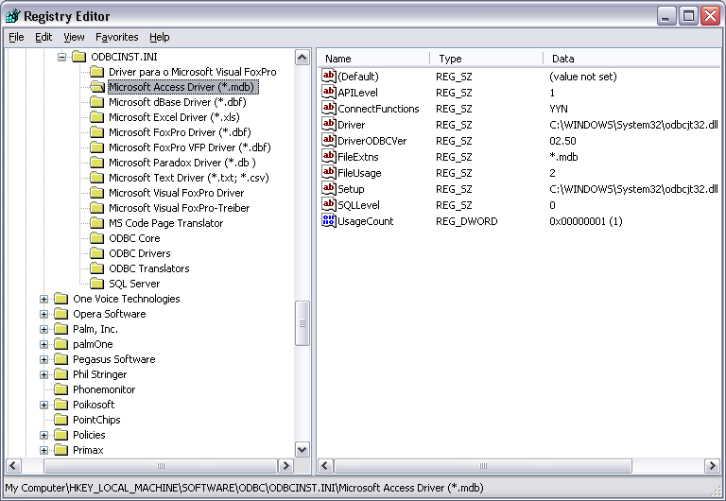

Check “Microsoft Access” key is missing, or the “driver or the value “C:\WINDOWS\System32\odbcjt32.dll”is missing,

In serious cases or registry corruptions, many or all of the ODBC keys will be messing.

Recovery

Please note that with serious problems, re-installing the latest MDAC package will NOT correct or replace missing registry entries. (It has been tried! )

(This is also the case if you attempt to re-install MS Access)

System or Registry Restore

Assuming that a regular system backup, or registry backup is taken, the solution is to simply recover to a “good” version. With XP, if the problem is recognised quickly this can be achieved using “Accessories – System Tools – System Restore"

Remember that this will restore all system files, or the whole registry. Any recent changes since the last backup will be lost !

Re-install Windows Operating System.

This is the last resort but WILL correct the problem. Hopefully you will not need a full re-install, the Windows installer should identify any components which need to be reinstalled and do a “refresh” only.

Reconstructing Registry Keys

This may be the only solution, if you cannot restore to a backup, or do not wish to re-install the Windows Operating system, (or some components).

The procedure is :

- Extract the ODBC registry keys from a good/clean system.

Using “regedit”, export the ODBC keys. Select the key and then “File-Export”. This will create a. ”.reg” file

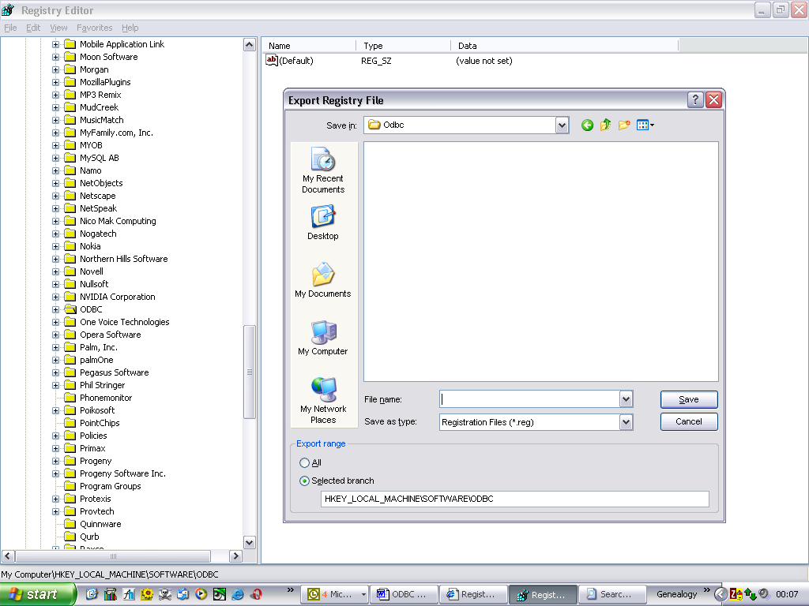

- Backup System Files or Registry

Using either the standard MS Windows backup, or a third party utilty, save, or backup the current systems files.

**** If this procedure fails, and the registry becomes corrupted, you will
**** need to restore to this point.
- Merging ODBC Registry Keys

Start “regedit” and import the ODBC registry keys, created in step 1.

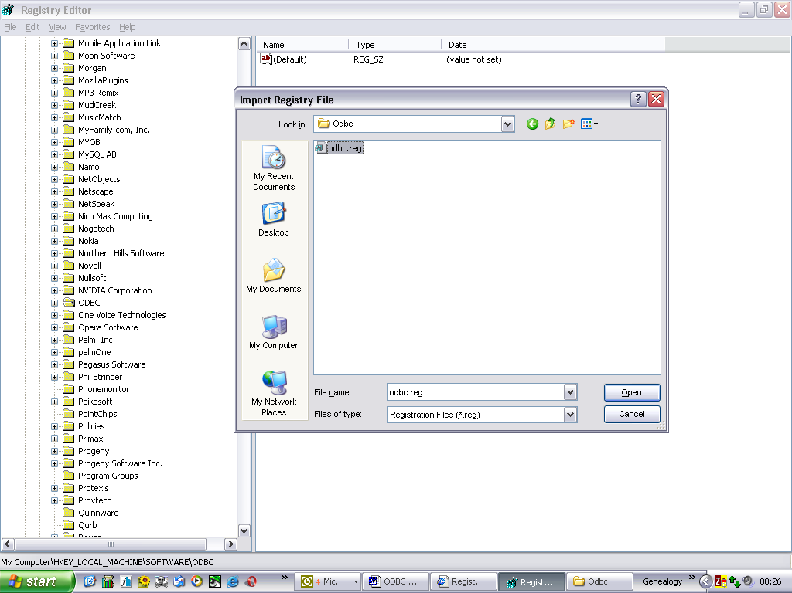
4. Check Results

Using “regedit”, check the ODBC registry keys.

Using “Data Sources (ODBC)” in Control Panel. On XP systems. For NT W2K ,
Check the drivers

- Backup System Files or Registry

Finally backup the system files or registry again. You do not want to lose all this work

Appendix

Microsoft ODBC URLS

- Registry Entries for ODBC Components

- MDAC Resets ODBC Registry Settings

- Desk Top Drivers (ODBC) Architecture

- Drivers and Data Sources

- MDAC Downloads

- MDAC Component Checker Utility

- Jet Database Engine Downloads

- A Very Useful Registry Editor

Acknowledgements

Kevin Phillips of Northern Hills Software LLC;.

Developers and Vendors of “Pocket Genealogist” for Pocket PC’s

Northern Hills Software LLC

Table of Contents

ODBC Drivers, MDAC. 1
Problems and Solutions 1
Symptom 2
Error creating database for Pocket Genealogist 2
Explanation. 3
Recovery 4
System or Registry Restore 4
Reconstructing Registry Keys 5
Appendix 9
Microsoft ODBC URLS 9
Acknowledgements 10

